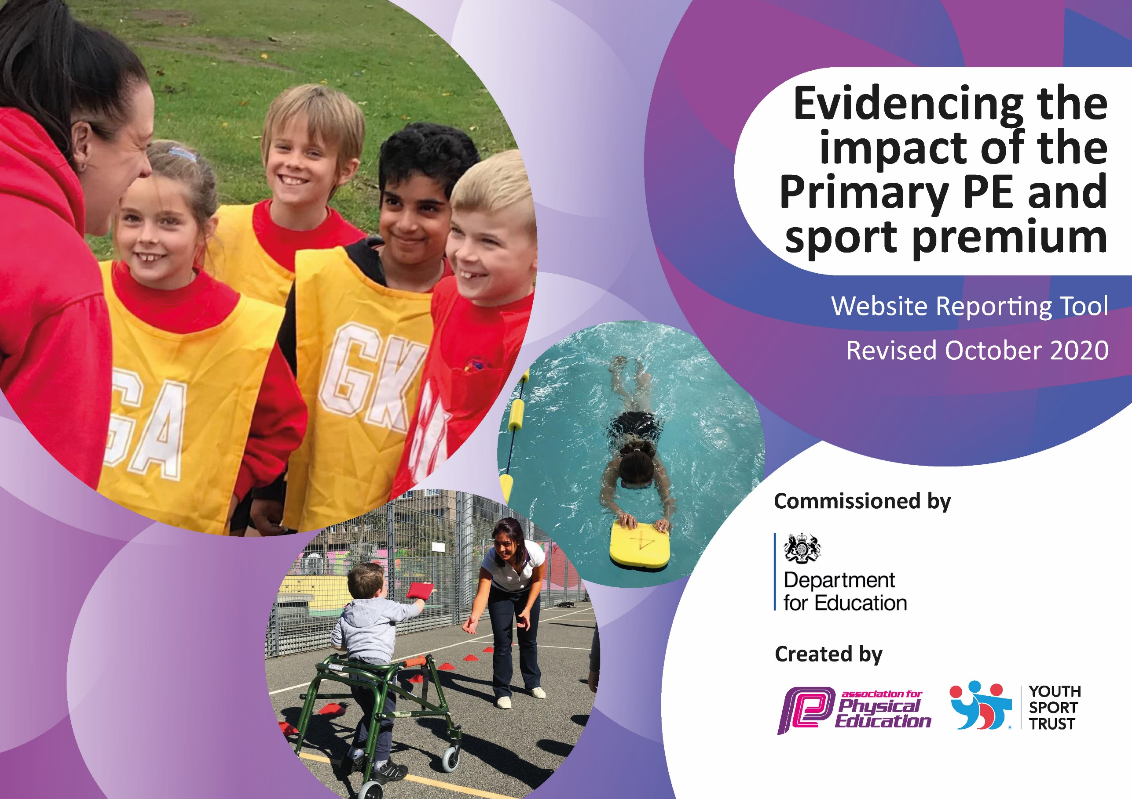
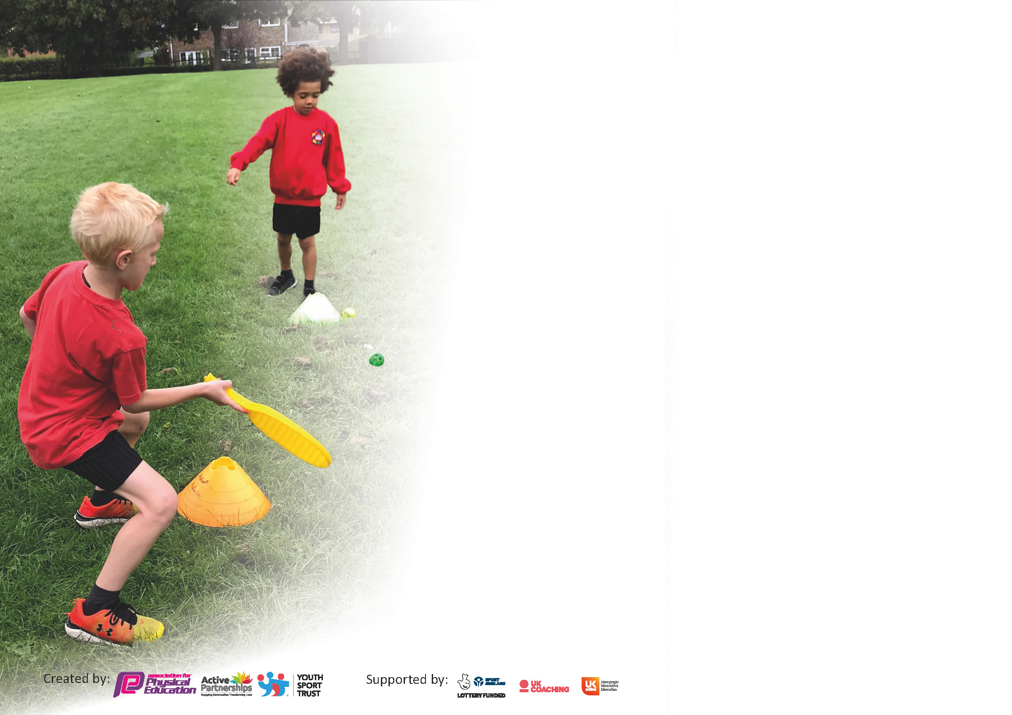

It is important that your grant is used effectively and based on school need. The Education Inspection Framework (Ofsted 2019 p64) makes clear there will be a focus on ‘whether leaders and those responsible for governors all understand their respective roles and perform these in a way that enhances the effectiveness of the school’.

Under the Quality of Education criteria (p41) inspectors consider the extent to which schools can articulate their curriculum (INTENT), construct their curriculum (IMPLEMENTATION) and demonstrate the outcomes which result (IMPACT).

To assist schools with common transferable language this template has been developed to utilise the same three headings which should make your plans easily transferable between working documents.

Schools must use the funding to make additional and sustainable improvements to the quality of Physical Education, School Sport and Physical Activity (PESSPA) they offer. This means that you should use
the Primary PE and sport premium to:

- Develop or add to the PESSPA activities that your school already offer
- Build capacity and capability within the school to ensure that improvements made now will benefit pupils joining the school in future years

Please visit gov.uk for the revised DfE guidance including the 5 key indicators across which schools should demonstrate an improvement. This document will help you to review your
provision and to report your spend. DfE encourages schools to use this template as an effective way of meeting the reporting requirements of the Primary PE and sport premium.

We recommend you start by reflecting on the impact of current provision and reviewing the previous spend.

Schools are required to publish details of how they spend this funding as well as on the impact it has on pupils’ PE and sport participation and attainment by the end of the summer term or by 31st July 2021 at the latest.

** In the case of any under-spend from 2019/20 which has been carried over this must be used and published by 31st March 2021.

We recommend regularly updating the table and publishing it on your website throughout the year. This evidences your ongoing self-evaluation of how you are using the funding to secure maximum, sustainable impact. Final copy must
be posted on your website by the end of the academic year and no later than the 31st July 2021. To see an example of how to complete the table please click HERE.
Created by: Supported by:

Please note: Although there has been considerable disruption in 2020 it is important that you publish details on your website of how you spend the funding - this is a legal requirement.
Support for review and reflection - considering the 5 key indicators from DfE, what development needs are a priority for your setting and your pupils now and why? Use the space below to reflect on previous spend and key achievements and areas for development.

N.B. In this section you should refer to any adjustments you might have made due to Covid-19 and how these will influence further improvement.
Key achievements to date until July 2020: | Areas for further improvement and baseline evidence of need:
- Implementation of Progression of skills across the school to support planning, rigorous sequencing of learning and assessment.  - Different staff had the opportunity to develop their CPD development due to Kanga Sports continuing to work with use throughout the lockdown.  - Schemes of work have been used by staff to help them plan first quality P.E lessons. | Develop our Year 5 and 6 children as Play Leaders – enabling them to lead, facilitate and model games at playtime and lunchtime within the defined zones.  Develop the playground environment to allow more opportunities to be active at play times and lunchtime – creating zones with high quality equipment and resources  Continue to increase staff CPD across range of areas. (including inclusive P.E)  Increase the physical development provision in the Early Years to ensure all children have the opportunity to reach their full potential physically. To include both fine and gross motor.

Did you carry forward an underspend from 2019-20 academic year into the current academic year? YES

If YES you must complete the following section
If NO, the following section is not applicable to you

If any funding from the academic year 2019/20 has been carried over you MUST complete the following section. Any carried over funding MUST be spent by 31 March 2021.
Academic Year: September 2020 to March 2021 | Total fund carried over:  £ 5000 | Date Updated: July 2021
Key indicator 1: The engagement of all pupils in regular physical activity – Chief Medical Officers guidelines recommend that primary school pupils undertake at least 30 minutes of physical activity a day in school |  |  |  | Total Carry Over Funding:
 |  |  |  | £ 5000
Intent | Implementation |  | Impact
Your school focus should be clear how you want to impact on your pupils.  Develop the playground environment to allow more opportunities to be active at play times and lunchtime – creating zones with high quality equipment and resources  Enhance the P.E and Sports equipment to allow more children access to high quality resources.  Enhance the Gymnastic equipment to allow more children access to high quality resources. | Make sure your actions to achieve are linked to your intentions:  The playground will set into zones with areas specifically designs to develop team games, Agility, Balance and Coordination. Along with a performing arts areas for dance and drama  The children will have access to high quality and more quantity of resources. This will allow the children to be more active during P.E lessons and develop their skills in line with the expectation for their year group. | Carry over funding allocated:  £3000  £2000 | Evidence of impact: How can you measure the impact on your pupils; you may have focussed on the difference that PE, SS & PA have made to pupils re-engagement with school. What has changed?  See impact below  As part of this money an interactive active board was purchase for outside. The children love using the board and the less active children were engaged in active activities at playtime. The board has also benefited children with social and emotional needs in a positive way.  The resources have enabled the children to access more high quality resources and the quantity has meant the children have been able to be more active during the their sessions.  We have not been able to benefit from the new Gymnastic equipment this year due to COVID 19 restrictions. We have not been able to use the hall. | Sustainability and suggested next steps and how does this link with the key indicators on which you are focussing this academic year?:  This action will allow the children to continue to be active during playtimes and lunchtimes. The children will be able to develop physically through accessing high quality resources designed to develop specific developmental areas.  An Additional active board will be purchased next year so more children can be active at one given time.  Resources will be continued to be purchased to ensure the children always have access to high quality and quantity of resources.  Hopefully from September 2021 will be able to use the hall again and benefit from the new equipment

Meeting national curriculum requirements for swimming and water safety.  N.B Complete this section to your best ability. For example you might have practised safe self-rescue techniques on dry land. | The year 5- 6 children were only able to attend 3 sessions Summer 2021 due to Covid 19 disruption
What percentage of your current Year 6 cohort swim competently, confidently and proficiently over a distance of at least 25 metres?  N.B. Even though your pupils may swim in another year please report on their attainment on leaving primary school at the end of the summer term 2021. | % - Unable to report 2021 due to Covid 19 disruption  As Year 5s - Autumn 2019 – 7 out of 17 achieved – 41%
What percentage of your current Year 6 cohort use a range of strokes effectively [for example, front crawl, backstroke and breaststroke]? | % - Unable to report 2021 due to Covid 19 disruption  As Year 5s - Autumn 2019 – 7 out of 17 achieved – 41%
What percentage of your current Year 6 cohort perform safe self-rescue in different water-based situations? | % - Unable to report 2021 due to Covid 19 disruption  As Year 5s - Autumn 2019 – 7 out of 17 achieved – 41%
Schools can choose to use the Primary PE and sport premium to provide additional provision for swimming but this must be for activity over and above the national curriculum requirements. Have you used it in this way? | Yes/No  This has not been possible this year due to Covid 19 restrictions

Action Plan and Budget Tracking
Capture your intended annual spend against the 5 key indicators. Clarify the success criteria and evidence of impact that you intend to measure to evaluate for pupils today and for the future.

Academic Year: 2020/21 | Total fund allocated: £ 17009 | Date Updated: July 2021
Key indicator 1: The engagement of all pupils in regular physical activity – Chief Medical Officers guidelines recommend that primary school pupils undertake at least 30 minutes of physical activity a day in school |  |  |  | Percentage of total allocation:
 |  |  |  | %
Intent | Implementation |  | Impact
Your school focus should be clear what you want the pupils to know and be able to do and about  what they need to learn and to  consolidate through practice: | Make sure your actions to achieve are linked to your intentions: | Funding allocated: | Evidence of impact: what do pupils now know and what can they now do? What has changed?: | Sustainability and suggested next steps:
Develop our Year 5 and 6 children as Play Leaders – enabling them to lead, facilitate and model games at playtime and lunchtime within the defined zones.  Develop the playground environment to allow more opportunities to be active at play times and lunchtime – Zones will be created.  Enhance the Early Years provision of physical development through purchasing gross motor equipment designed to support the development of the children. | All of Oak class will be trained up as play leaders so they will be able to lead active sessions at playtimes and lunchtimes.  The playground will set into zones with areas specifically designed to develop Team Games, Agility, Balance and Coordination. Along with a Performing Arts area for dance and drama.  The children in the Early Years will have access to more high quality physical development resources. Also this will allow the children more opportunities to be active and to develop their physical well-being. | £6000  £1000 | This has been limited this year due to Covid 19 restrictions. Oak class have not been able to mix with the younger children in the school to implement.  This was partially implemented with great success.  This was only able to be implemented with Years 2, 3 and 4 due to being in bubbles and not being able to share equipment with other bubbles. In addition, some of the equipment ordered had still not been delivered in the Summer Term. Alongside this building work caused disruption closing off the Early Years outdoor provision resulting in them using part of the playground to fulfil their requirements.  We were able to zone two areas  - Zone 1 Games  - Zone 2 Agility  In Zone 1 a timetable was set up with a different game each day. This was very successful with the children taking part in active games eg hockey, football, dodgeball daily. The older children in the group took on the role of referee. Feedback from the children has been very positive and they loved having different games each day allowing them to more active.  Zone 2 has allowed the children to work on their Agility skills – this has enabled the less sporty children to become active at playtimes.  The zoning has had a great impact on the children’s physical and mental wellbeing making them more active in the playground and a has also had a positive impact on the children’s behaviour.  Agility blocks were purchased during the summer term (still waiting for them to be delivered) These will enable the children to develop their agility – agility, balance and coordination as well as cooperation skills. | This will continue next year when hopefully the whole school can join together again for playtimes and lunch times.  This action will allow the children to continue to be active during playtimes and lunchtimes. The children will be able to develop physically through accessing high quality resources designed to develop specific developmental areas.  The children will continue to access the resources to develop their physical development  Agility blocks were purchase in the summer term. Impact will monitored during the Autumn term 2021
Key indicator 2: The profile of PESSPA being raised across the school as a tool for whole school improvement |  |  |  | Percentage of total allocation:
 |  |  |  | %
Intent | Implementation |  | Impact
Your school focus should be clear what you want the pupils to know and be able to do and about  what they need to learn and to  consolidate through practice: | Make sure your actions to achieve are linked to your intentions: | Funding allocated: | Evidence of impact: what do pupils now know and what can they now do? What has changed?: | Sustainability and suggested next steps:
Develop our Year 5 and 6 children as Play Leaders – enabling them to lead, facilitate and model games at playtime and lunchtime within the defined zones.  Develop the playground environment to allow more opportunities to be active at play times and lunchtime – Zones will be created. | All of year 6 will be trained up as play leaders so they will be able to lead active sessions at playtimes and lunchtimes.  The playground will set into zones with areas specifically designed to develop Team Games, Agility, Balance and Coordination. Along with a Performing Arts area for dance and drama. | Non  See above | This has been limited this year due to Covid 19 restrictions. Oak class have not been able to mix with the younger children in the school to implement.  See above for the impact. | This will continue next year when hopefully the whole school can join together again for playtimes and lunch times.  This action will allow the children to continue to be active during playtimes and lunchtimes. The children will be able to develop physically through accessing high quality resources designed to develop specific developmental areas.  This will be developed further throughout the next year when hopefully the whole school can be together and all the zones set up.

Key indicator 3: Increased confidence, knowledge and skills of all staff in teaching PE and sport |  |  |  | Percentage of total allocation:
 |  |  |  | %
Intent | Implementation |  | Impact
Your school focus should be clear | Make sure your actions to | Funding | Evidence of impact: what do | Sustainability and suggested
what you want the pupils to know | achieve are linked to your | allocated: | pupils now know and what | next steps:
and be able to do and about | intentions: |  | can they now do? What has
what they need to learn and to |  |  | changed?:
consolidate through practice:
Provide staff with CPD – working along a P.E and Sports Specialist.  Developing staff CPD will enable them to have the confidence to teach a range of sports and skills to a high standard. In turn this will improve the skills and physical development of all our children | The P.E Specialist will work with our staff in order that they meet Teacher standards in PE and that PE lessons delivered by them are judged ‘Good’ /Outstanding against Ofsted criteria.  In addition, this will facilitate targeted provision of more able pupils in these lessons due to additional adult support.  Schemes of work provided from the specialist to support future teaching by the staff.  This will also support us in achieving more success in the local sports tournaments. | £3100 - to fund specialist sports teacher for 0.5 days per week, (Kanga Sports).  Full Afternoon - £35 per hour - 2 hours - £70 | Throughout the year we have been able to continue with CDP for Staff.  The staff have been able to develop their knowledge and skills in specific areas of need within the P.E curriculum. This has resulted in the staff being able to deliver high quality lessons with confidence. | This will continue next year tailored to the staffs CPD areas of development.  Due to Covid 19 restrictions, we have not been able to deliver gymnastics or some dance to the children indoors. With this in mind some CPD will involve these elements.
Key indicator 4: Broader experience of a range of sports and activities offered to all pupils |  |  |  | Percentage of total allocation:
 |  |  |  | %
Intent | Implementation |  | Impact
Your school focus should be clear | Make sure your actions to | Funding | Evidence of impact: what do | Sustainability and suggested
what you want the pupils to know | achieve are linked to your | allocated: | pupils now know and what | next steps:
and be able to do and about | intentions: |  | can they now do? What has
what they need to learn and to |  |  | changed?:
consolidate through practice:
After school sports providing a range of different sports.  Increase the number of children attending sports clubs after school, therefore being more active and supporting their well-being.  The additional skills learnt at the clubs will help the children to be more successful at the local schools sports tournaments.  Engage targeted children in year 5 in Active Maths. The children will be working on specific maths targets tailored to their needs while being active. | Run two after school clubs split into Key stage 1 and 2  The two clubs will allow more children to patriciate and allow us to target the less active children.  Running two clubs will allow the children to become more engaged as the skills and sports can be targeted at their needs.  The children will attend a morning Active Maths Club run by Kanga Sport once a week.  The club is specifically tailored to the children mathematical areas of development. These are assessed weekly. | £1800  To provide 2 sporting after school clubs  KS1 – 2 sports specialists  KS2 – 1 sports specialist  1 Sports club ran in the Autumn Term  1 sports club ran in the Summer term  Active maths morning club – Summer Term | Sports after school clubs ran for part of the Autumn term for Year 2, 3 and 4 only due to Covid 19 restrictions with a maximum of 15 children allowed to attend.  Sports after school were unable to run in the Spring term due to Covid 19 restrictions.  Sports after school resumed in the Summer Term for Year 5 and 6 then Year 2, 3 and 4 with a maximum of 15 children allowed attending.  The clubs have been available for not only for the children physical well-being but for their mental well-being and the children that attended benefitted greatly from this.  The club has supported the children’s physical and mental well-being as well are strengthening their mathematical skills.  Progress in Maths KPIs and summative assessment of each child have shown this. | Hopefully from September 2021 clubs will be able to continue allowing us to run two clubs again. One for KS1 and another for KS2  The active maths club was successful and resulted in the children making improvements in the mental maths along with being active.  The Active Maths club will continue – we will be targeting year 4 children this year.

Key indicator 5: Increased participation in competitive sport |  |  |  | Percentage of total allocation:
 |  |  |  | %
Intent | Implementation |  | Impact
Your school focus should be clear | Make sure your actions to | Funding | Evidence of impact: what do | Sustainability and suggested
what you want the pupils to know | achieve are linked to your | allocated: | pupils now know and what | next steps:
and be able to do and about | intentions: |  | can they now do? What has
what they need to learn and to |  |  | changed?:
consolidate through practice:
Increase participation in competitive sport. | For the school to compete in the School Games Programme.  Dedicated leadership time for a Secondary Colleague (South Craven Academy) to coordinate inter-school tournaments between 12 local primary schools. (School pays the local secondary school to coordinate the tournaments.)  Release time given to the P.E leader This will enable the children to attend more tournaments. | Total £600  £200  To support ‘cluster’ events between schools  14 hours – £400 Teacher rate | Not able to take part in competitive sports with other schools due to Covid 19 restrictions.  The money will be spent on equipping the playground promoting more active playtimes and lunchtimes. | Hopefully Competitive sports with other schools will be able to resume from September 2021.

Signed off by
Head Teacher: | Mrs Orla Gibbons
Date: | July 2021
Subject Leader: | Miss Paula Margetson
Date: | July 2021
Governor: | Mr Simon Garner (Chair)
Date: | July 2021

